Calendrier Annuel prévisionnel de stage
Filière : Infirmier Polyvalent | Année Scolaire : 2026/2027 (3ème Année)
Section : Technicien spécialisé | Année de formation : 2024/2027

Service | Médecine | Chirurgie | Réanimation médicale | Réanimation chirurgicale | Pédiatrie | Urgence | Gynécologie | Obstétrique | Médecine  (Derma) | Chirurgie  (Ophta) | Chirurgie  (ORL) | Hemodialysis | C.S | C.S | Rural
05/10/2026 14/10/2026 | G:A  Edderrak | G:B  Edderrak | G:C  ibno roched | G:D  mooulouya | G:E | G:F | G:G | G:H | G:I | - | - | - | - | - | -
 |  |  |  |  | Edderrak | Edderrak | Edderrak | ibno roched | Edderrak
15/10/2026 22/10/2026 |  |  |  |  | G:F | G:E | G:H | G:G | - | G:I
 |  |  |  |  | Edderrak | Edderrak | Edderrak | ibno roched | - | Edderrak
23/10/2026 03/11/2026 | G:I  ibno roched | G:A  mooulouya | G:B  ibno roched | G:C  ibno roched | G:D | - | G:E | G:F | G:G | G:H | - | - | - | - | -
 |  |  |  |  | Edderrak | - | mooulouya | ibno roched | Edderrak | Edderrak
04/11/2026 19/11/2026 |  |  |  |  | - | G:D | G:F | G:E | G:H | G:G
 |  |  |  |  |  | Edderrak | _{mooulouya} | ibno roched | Edderrak | Edderrak
20/11/2026 27/11/2026 | G:G  mooulouya | G:H  mooulouya | G:A  ibno roched | G:B  ibno roched | G:C | G:I | G:D | - | G:E | G:F | - | - | - | - | -
 |  |  |  |  | Edderrak | mooulouya | ibno roched | - | Edderrak | Edderrak
30/11/2026 15/12/2026 |  |  |  |  | G:I | G:C | - | G:D | G:F | G:E
 |  |  |  |  | Edderrak | mooulouya | - | Edderrak | Edderrak | Edderrak
16/12/2026 23/12/2026 | G:E  mooulouya | G:F  ibno roched | G:G  ibno roched | G:A  mooulouya | G:B | G:H | G:C | G:I | G:D | - | - | - | - | - | -
 |  |  |  |  | Edderrak | ibno roched | Edderrak | mooulouya | Edderrak
24/12/2026 04/01/2027 |  |  |  |  | G:H | G:B | G:I | G:C | - | G:D
 |  |  |  |  | Edderrak | ibno roched | Edderrak | mooulouya | - | Edderrak
05/01/2027 18/01/2027 | G:D  mooulouya | G:E  ibno roched | G:F  mooulouya | G:G  mooulouya | G:A | - | G:B | - | G:C | - | - | - | G:H | G:I | -
 |  |  |  |  | Edderrak | - | Edderrak | - | Edderrak
19/01/2027 03/02/2027 |  |  |  |  | - | G:A | - | G:B | - | G:C
 |  |  |  |  |  | Edderrak | - | mooulouya | - | Edderrak
04/02/2027 11/02/2027 | - | G:G  ibno roched | G:H  mooulouya | G:I  mooulouya | - | - | G:A | - | G:B | - | - | - | G:C | G:E+ G:D | G:F
 |  |  |  |  |  |  | mooulouya | - | Edderrak
12/02/2027 18/02/2027 |  |  |  |  |  |  | - | G: A | - | G:B
 |  |  |  |  |  |  |  | Edderrak | - | Edderrak
19/02/2027 25/02/2027 | G:H  ibno roched | G:I  mooulouya | G:E  mooulouya | G:F  mooulouya | G:G | - | - | - | G:A | - | - | - | G:B | G:C | G:D
 |  |  |  |  | Edderrak | - | - | - | Edderrak
26/02/2027 13/03/2027 |  |  |  |  | - | G:G | - | - | - | G:A
 |  |  |  |  |  | Edderrak | - | - | - | Edderrak
22/03/2027 30/03/2027 | G:F  mooulouya | G:D  ibno roched | G:I  mooulouya | G:E  ibno roched | - | - | - | - | - | - | G:G+ G:H | - | G:A | G:B | G:C
 |  |  |  |  |  |  |  |  |  |  | Edderrak
31/03/2027 06/04/2027 |  |  |  |  |  |  |  |  |  |  | - | G:G+ G:H | G:A | G:B | G:C
07/04/2027 14/04/2027 | G:C  ibno roched | - | G:D  ibno roched | - | - | - | - | - | - | - | G:E+ G:F | - | G:I+ G:G | G:A | G:B+ G:H
 |  |  |  |  |  |  |  |  |  |  | Edderrak
15/04/2027 22/04/2027 |  |  |  |  |  |  |  |  |  |  | - | G:E+ G:F | G:I+ G:G | G:A | G:B+ G:H
23/04/2027 29/04/2027 | G:B  ibno roched | G:C  mooulouya | - | G:H  ibno roched | - | - | - | - | - | - | G:D+ G:I | - | G:E | G:F+ G:G | G:A
 |  |  |  |  |  |  |  |  |  |  | Edderrak
10/05/2027 20/05/2027 |  |  |  |  |  |  |  |  |  |  | - | G:D+ G:I | G:E | G:F+ G:G | G:A
21/05/2027 01/06/2027 | - | - | - | - | - | - | - | - | - | - | G:A+ G:B+ G:C | - | G:D+ G:F | G:H | G:E+ G:G+ G:I
 |  |  |  |  |  |  |  |  |  |  | Edderrak
02/06/2027 09/06/2027 |  |  |  |  |  |  |  |  |  |  |  | G:A+ G:B+ G:C | G:D+ G:F | G:H | G:E+ G:G+ G:I
10/06/2027 17/06/2027 |  | Stage optionnel

Cachet et signature

Liste groupes des stagiaires
Filière : Infirmier Polyvalent | Année Scolaire : 2026/2027(3ème Année )
Section : Technicien spécialisé | Année de formation : 2024/2027

A | 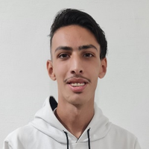 | 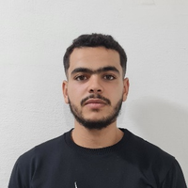 | F | 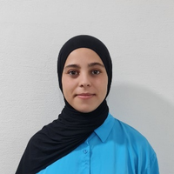 | 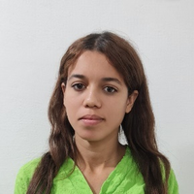
A | Oussama MESSAOUDI | Abdessamie BOUAYYADY | F | Imane AARAB | Maissae AFKIR
B | 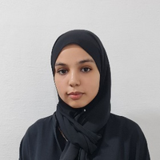 | 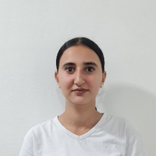 | G | 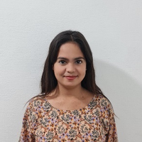 | 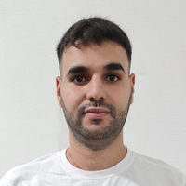
B | Khaoula BOUMEDIENE | Marieme EL-AOUNI | G | Marwa MOURAD | Smail JBARA
C | 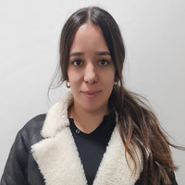 | 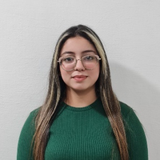 | H | 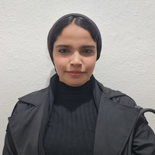 | 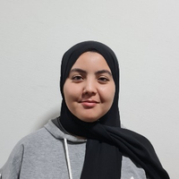
C | Lamiae DRIOUACH | Romayssae EL-FILALI | H | Manal BOUARFA | Aya KIRAT
D | 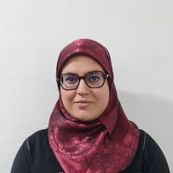 | 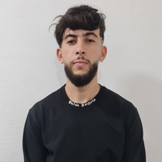 | I | 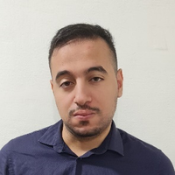 | 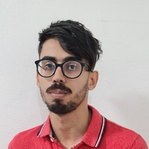
D | Fatima Zahra El Gasmi | Aymane BEKKAOUI | I | Youssef BOUMAAZA | Othmane BENSALAH
E | 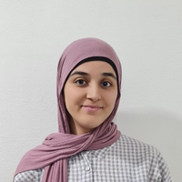 | 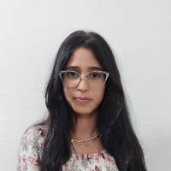
E | Lamyaae MARGOUM | Ghariba LAARAJ

Cachet et signature

Calendrier Annuel prévisionnel de stage
Filière : Infirmier Polyvalent | Année Scolaire : 2026/2027 (2ème Année)
Section : Technicien spécialisé | Année de formation : 2025/2028

Service | Médecine | Chirurgie | Pédiatrie | BlOC | Obstétrique | PF | CS
05/10/2026 14/10/2026 | _{G:A + G: H}  ibno roched+mooulouya | _{G:B + G:I}  mooulouya+ Edderrak | _{G:C + G:J}  Edderrak | _{G:F}  Moulouya | _{G:D} | _{G:E} | _{G:G}
 |  |  |  |  | mooulouya | _{G:E} | _{G:G}
15/10/2026 22/10/2026 |  |  |  |  | _{G:E} | _{G:D} | _{G:G}
 |  |  |  |  | mooulouya | _{G:D} | _{G:G}
23/10/2026 03/11/2026 | _{G:G}  Edderrak | _{G:A + G: H}  mooulouya+ Edderrak | _{G:B + G:I}  Edderrak | _{G:D}  mooulouya | _{G:C + G:J} | _{G:F} | _{G:E}
 |  |  |  |  | mooulouya+ ibno roched | _{G:F} | _{G:E}
04/11/2026 19/11/2026 |  |  |  |  | _{G:F} | _{G:C + G:J} | _{G:E}
 |  |  |  |  | Edderrak | _{G:C + G:J} | _{G:E}
20/11/2026 27/11/2026 | _{G:E + G:I}  Edderrak+ mooulouya | _{G:F}  Edderrak | _{G:A + G:H}  Edderrak | _{G:C + G: J}  Edderrak | _{G:B} | _{G:G} | _{G:D}
 |  |  |  |  | ibno roched | _{G:G} | _{G:D}
30/11/2026 15/12/2026 |  |  |  |  | _{G:G} | _{G:B} | _{G:D}
 |  |  |  |  | ibno roched | _{G:B} | _{G:D}
16/12/2026 23/12/2026 | _{G:D}  Edderrak | _{G:E}  ibno roched | _{G:F + G:G}  Edderrak | _{G:B + G:I}  ibno roched + Edderrak | _{G:A} | _{G:H} | _{G:C + G:J}
 |  |  |  |  | Edderrak | _{G:H} | _{G:C + G:J}
24/12/2026 04/01/2027 |  |  |  |  | _{G:H} | _{G:A} | _{G:C + G:J}
 |  |  |  |  | Edderrak | _{G:A} | _{G:C + G:J}
05/01/2027 18/01/2027 | _{G:F + G:C + G:J}  mooulouya+ ibno roched+ Edderrak | _{G:D + G:G}  ibno roched+ mooulouya | _{G:E}  Edderrak | _{G:A + G:H}  ibno roched + Edderrak | — | — | _{G:B + G:I}
19/01/2027 03/02/2027
04/02/2027 11/02/2027 | _{G:B}  Edderrak | _{G:C + G:J}  Edderrak+ ibno roched | _{G:D}  Edderrak | _{G:E + G:G}  ibno roched +mooulouya | _{G:I} | — | _{G:H + G:A + G:F}
 |  |  |  |  | Edderrak | — | _{G:H + G:A + G:F}
12/02/2027 18/02/2027 |  |  |  |  | — | _{G:I} | _{G:H + G:A + G:F}
19/02/2027 25/02/2027 | — | — | — | _{G:A+ G:B} | _{G:C+ G:D} | _{G:E+ G:F}  _{G:G+ G:H} | _{G:I+ G:J}
 |  |  |  | Edderrak | Edderrak | _{G:E+ G:F}  _{G:G+ G:H} | _{G:I+ G:J}
26/02/2027 13/03/2027 | — | — | — | _{G:C+ G:D} | _{G:E+ G:F} | _{G:I+ G:J} | _{G:A+ G:B G:G+ G:H}
 |  |  |  | ibno roched +Edderrak | Edderrak+ ibno roched | _{G:I+ G:J} | _{G:A+ G:B G:G+ G:H}
22/03/2027 30/03/2027 | — | — | — | _{G:E+ G:F /G:I+ G:J} | _{G:G+ G:H} | _{G:A+ G:B} | _{G:C+ G:D}
 |  |  |  | Edderrak / mooulouya | Edderrak+ mooulouya | _{G:A+ G:B} | _{G:C+ G:D}
31/03/2027 06/04/2027 | — | — | — | _{G:G+ G:H} | _{G:A+ G:B+ G:I+ G:J} | _{G:C+ G:D} | _{G:E+ G:F}
 |  |  |  | Edderrak +ibno roched | ibno roched + Edderrak+ mooulouya + Edderrak | _{G:C+ G:D} | _{G:E+ G:F}
07/04/2027 14/04/2027 | _{G:A+ G:B} | _{G:C+ G:D} | — | — | _{G:E+ G:F} | _{G:G+ G:H} | _{G:I+ G:J}
07/04/2027 14/04/2027 | Edderrak+ ibno roched | Edderrak | — | — | ibno roched | _{G:G+ G:H} | _{G:I+ G:J}
15/04/2027 22/04/2027 | _{G:E+ G:F} | _{G:G+ G:H} | — | — | _{G:I+ G:J} | _{G:A+ G:B} | _{G:C+ G:D}
15/04/2027 22/04/2027 | ibno roched + Edderrak | Edderrak+ mooulouya | — | — | mooulouya | _{G:A+ G:B} | _{G:C+ G:D}
23/04/2027 29/04/2027 | _{G:I+ G:J} | _{G:E+ G:F} | — | — | _{G:A+ G:B} | _{G:C+ G:D} | _{G:G+ G:H}
23/04/2027 29/04/2027 | Edderrak+ ibno roched | Edderrak+ mooulouya | — | — | mooulouya | _{G:C+ G:D} | _{G:G+ G:H}
10/05/2027 20/05/2027 | _{G:C+ G:D} | _{G:I+ G:J} | — | — | _{G:G+ G:H} | _{G:E+ G:F} | _{G:A+ G:B}
10/05/2027 20/05/2027 | Edderrak+ibno roched | mooulouya + Edderrak | — | — | ibno roched | _{G:E+ G:F} | _{G:A+ G:B}
21/05/2027 01/06/2027 | _{G:G+ G:H} | _{G:A+ G:B} | — | — | _{G:C+ G:D} | _{G:I+ G:J} | _{G:E+ G:F}
21/05/2027 01/06/2027 | ibno roched + Edderrak | Edderrak | — | — | ibno roched | _{G:I+ G:J} | _{G:E+ G:F}
02/06/2027 09/06/2027 | — | — | — | — | — | _{G:A+ G:B G:G+ G:H} | _{G:C+ G:D G:E+ G:F G:I+ G:J}
10/06/2027 17/06/2027
Cachet et signature :
Liste groupe des stagiaires
Filière : Infirmier Polyvalent | Année Scolaire : 2026/2027 (2ème Année )
Section : Technicien spécialisé | Année de formation : 2025/2028

A | 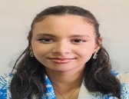 | 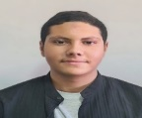 | G | 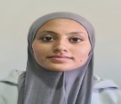 | 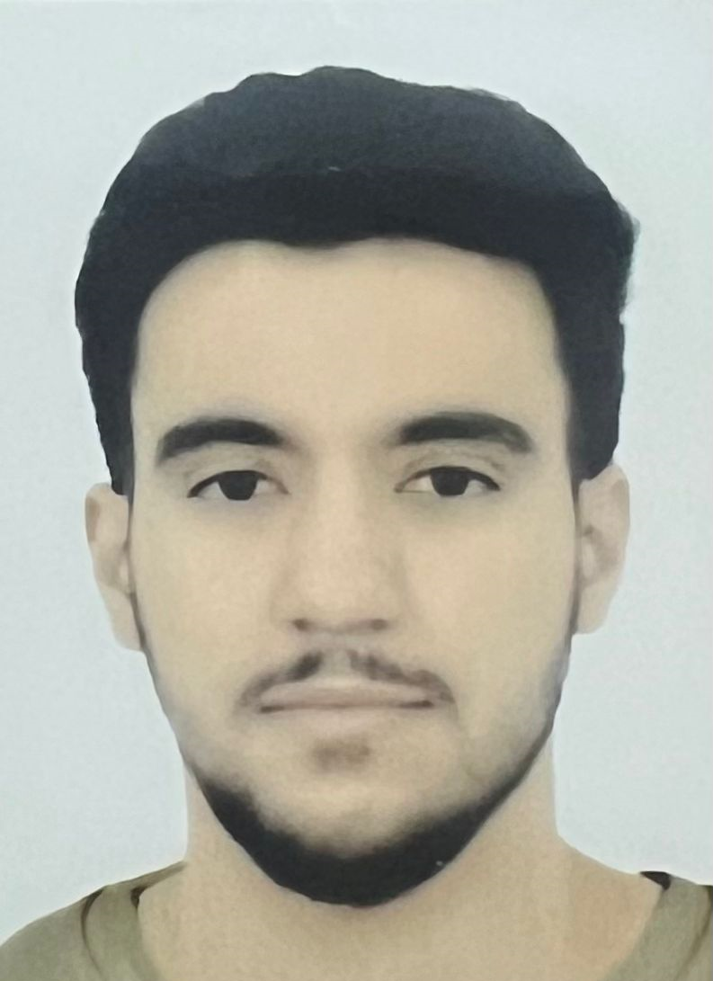
A | Samiha EL JAIMI | Mohammed RAHHAOUI | G | Kaoutar MAAROUFI | Oussama BEDDOURI
B | 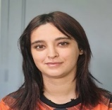 |  | H | 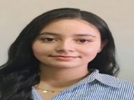 | 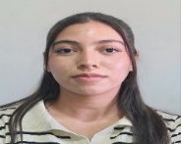
B | Ikram ELYAMANI | Aymen GUECHCHATI | H | Meryame BERKANI | Salma BINDECHE
C | 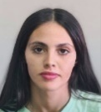 | 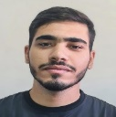 | I | 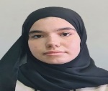 | 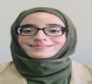
C | Chaymae Asaidi | Ayoub SETTI | I | Fatima-Zahra LATRECH | Fatima-Zahra AHADRI
D | 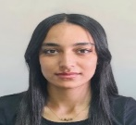 | 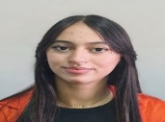 | J | 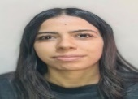 | 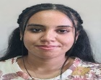
D | Rofayda EL HADAD | Imane BELHAJ |  | Salima BELMUSTAPHA | Souad MOUADDAH
E | 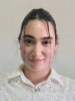 | 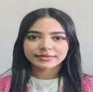
E | Salma MAKHLOUFI | Sanae RABHI
F |  | 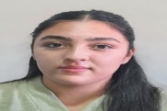
F | Salma BOURHALEB | IMANE BOUSETTA
Cachet et signature :

Calendrier Annuel prévisionnel de stage
Filière : Infirmier Auxiliaire | Année Scolaire : 2026/2027 (2ème année)
Section : Technicien | Année de formation : 2025/2027

Service | Médecine | Chirurgie | Pédiatrie | Urgences | Réanimation | Maternité | CS | Dispensaire | Référence | Rural | Rural
05/10/2026 14/10/2026 | — | — | — | — | — | — | — | _{G:A} | _{G:B} | _{G:C} | _{G:D}
15/10/2026 22/10/2026
23/10/2026 03/11/2026 | — | — | — | — | — | — | — | _{G:D} | _{G:A} | _{G:B} | _{G:C}
04/11/2026 19/11/2026
20/11/2026 27/11/2026 | — | — | — | — | — | — | — | _{G:C} | _{G:D} | _{G:A} | _{G:B}
30/11/2026 15/12/2026
16/12/2026 23/12/2026 | — | — | — | — | — | — | — | _{G:B} | _{G:C} | _{G:D} | _{G:A}
24/12/2026 04/01/2027
05/01/2027 18/01/2027 | _{G:A}  _{Edderrak} | _{G:B}  _{Edderrak} | _{G:C}  _{Edderrak} | _{G:D} | — | — | — | — | — | — | —
 |  |  |  | _{Edderrak}
19/01/2027 03/02/2027 | _{G:A}  _{Edderrak} | _{G:B}  _{Edderrak} | _{G:C}  _{Edderrak} | — | _{G:D}
 |  |  |  |  | _{ibno roched}
04/02/2027 11/02/2027 | _{G:D}  _{Edderrak} | _{G:A}  _{Edderrak} | _{G:B}  _{Edderrak} | _{G:C} | — | — | — | — | — | — | —
 |  |  |  | _{Edderrak}
12/02/2027 18/02/2027 | _{G:D}  _{Edderrak} | _{G:A}  _{Edderrak} | _{G:B}  _{Edderrak} | — | _{G:C}
 |  |  |  |  | _{mooulouya}
19/02/2027 25/02/2027 | _{G:C}  _{Edderrak} | _{G:D}  _{Edderrak} | _{G:A}  _{Edderrak} | _{G:B} | — | — | — | — | — | — | —
 |  |  |  | _{Edderrak}
26/02/2027 13/03/2027 | _{G:C}  _{Edderrak} | _{G:D}  _{Edderrak} | _{G:A}  _{Edderrak} | — | _{G:B}
 |  |  |  |  | _{ibno roched}
22/03/2027 30/03/2027 | _{G:B}  _{Edderrak} | _{G:C}  _{Edderrak} | _{G:D}  _{Edderrak} | _{G:A} | — | — | — | — | — | — | —
 |  |  |  | _{Edderrak}
31/03/2027 06/04/2027 | _{G:B}  _{Edderrak} | _{G:C}  _{Edderrak} | _{G:D}  _{Edderrak} | — | _{G:A}
 |  |  |  |  | _{mooulouya}
07/04/2027 14/04/2027 | _{G:B}  _{mooulouya} | _{G:C}  _{ibno roched} | — | _{G:D} | — | _{G:A} | — | — | — | — | —
 |  |  |  | _{Edderrak} | — | _{mooulouya}
15/04/2027 22/04/2027 | _{G:B}  _{mooulouya} | _{G:C}  _{ibno roched} | — | — | _{G:D} | — | _{G:A}
 |  |  |  |  | _{mooulouya}
23/04/2027 29/04/2027 | _{G:A}  _{ibno roched} | _{G:D}  _{mooulouya} | _{G:C}  _{Edderrak} | — | — | _{G:B} | — | — | — | — | —
 |  |  |  |  |  | _{ibno roched}
10/05/2027 20/05/2027 |  |  |  |  |  | — | _{G:B}
21/05/2027 01/06/2027 | _{G:D}  _{ibno roched} | _{G:A}  _{mooulouya} | _{G:B}  _{Edderrak} | — | — | _{G:C} | — | — | — | — | —
 |  |  |  |  |  | _{mooulouya}
02/06/2027 09/06/2027 |  |  |  |  |  | — | _{G:C}
10/06/2027 17/06/2027 | _{G:C}  _{ibno roched} | _{G:B}  _{ibno roched} | _{G:A}  _{Edderrak} | — | — | _{G:D} | — | — | — | — | —
 |  |  |  |  |  | _{ibno roched}
18/06/2027 25/06/2027 |  |  |  |  |  | — | _{G:D}
26/06/2027  15/07/2027 | Stage optionnel

Cachet et signature

Liste des groupes des stagiaires
Filière : | Infirmier Auxiliaire (2ème année)
Année scolaire : | 2026/2027
Promotion : | 2025/2027

Groupe  A | 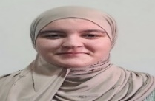 | 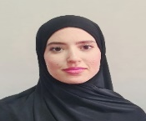
Groupe  A | Malika BOUTA | Douae SNOUBRI
Groupe  B |  | 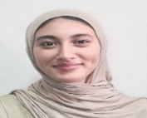 | 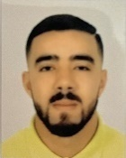
Groupe  B | Siham DERAOUI | Rihab EL HASSOUNI | MOHAMMED MAAROUF
Groupe  C | 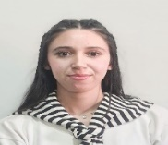 |  | 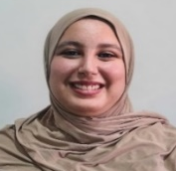
Groupe  C | Salma Charai | Safae GUAADAOUI | Fadoua KISSI
Groupe  D | 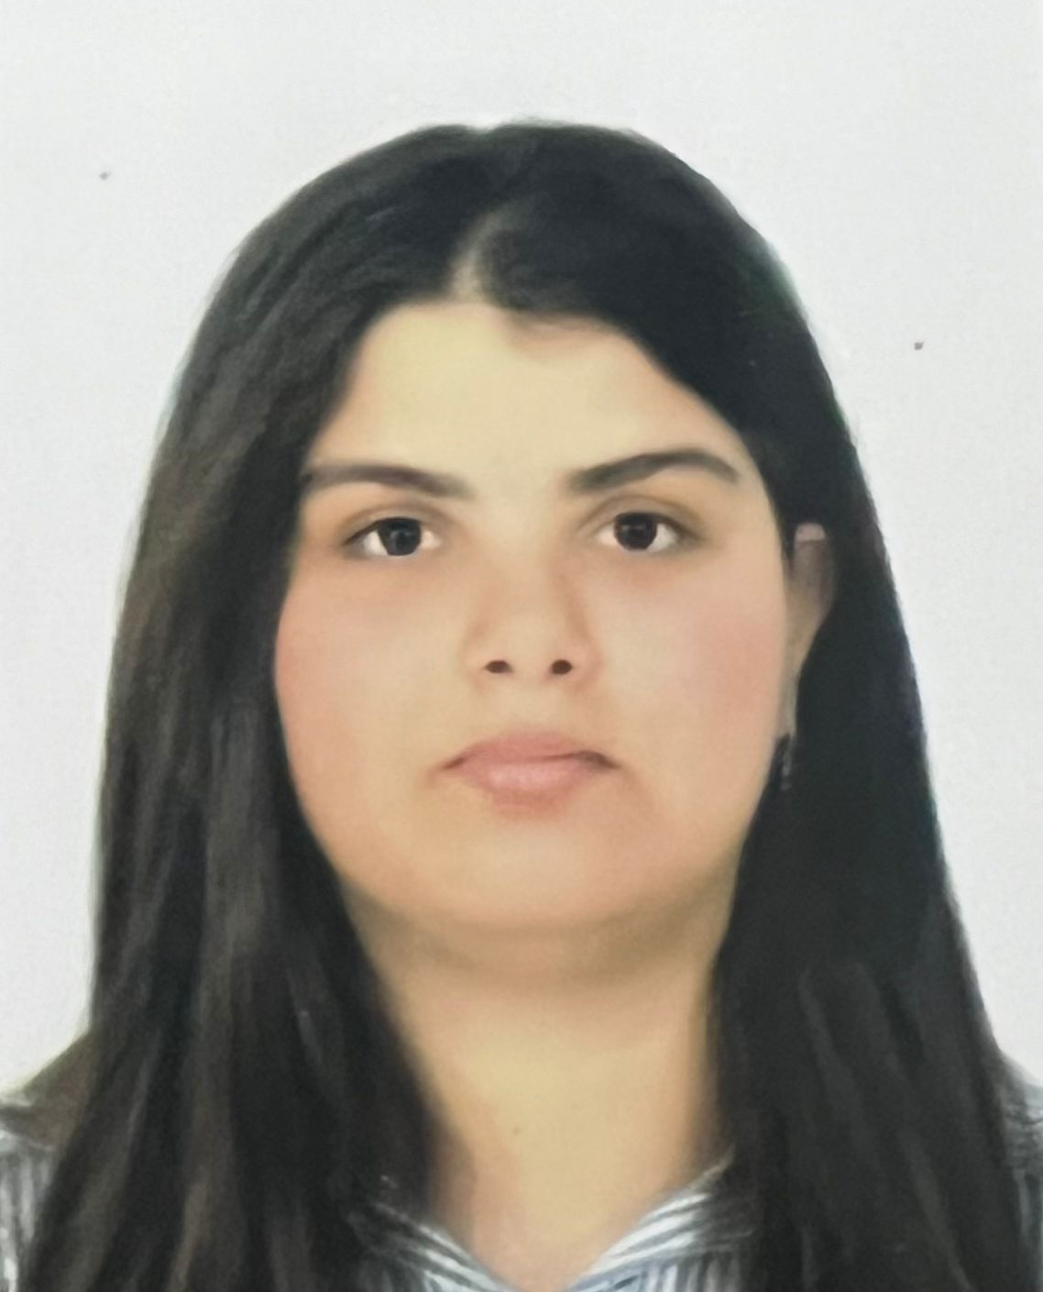
Groupe  D | Salma BAADI

Cachet et signature :

